DRAFT DOCUMENT

HOUSING REVENUE ACCOUNT BUSINESS PLAN

2012-2042

This document is a working draft for the final HRA business plan. The main changes to the document are in the areas of resident consultation, development programme and borrowing assumptions.

Version CEB 2.0 working draft
Contents

Executive Summary 3
1 Introduction 4
2 Economic and Policy Context 6
2.1 Economic context 6
2.2 National policy 6
2.3 Local Policy 9
2.4 Regulation of social housing 11
3 Housing Need and Supply 12
3.1 Our tenants and leaseholders 12
3.2 Local Housing Market 12
3.3 Need for social housing in Oxford 13
4 Council’s Housing Assets 14
4.1 Council Stock 14
4.2 Stock Condition: Planned and Responsive Maintenance 15
4.3 Projected Stock Condition 21
4.4 Delivering energy efficiency in our homes 23
5 Governance and Consultation 25
5.1 Governance 25
5.2 Resident involvement 25
5.3 Executive 26
5.4 Business Plan Priorities 27
6 Performance and Service Delivery 29
6.1 Performance measurement 29
6.2 Service Improvement Planning 31
7 Resources 32
7.1 Capital Payment and Borrowing Cap 32
7.2 Treasury Management: Funding the Capital Payment and Borrowing 33
8 Self Financing Housing Model 35
8.1 Income 35
8.2 Expenditure 37
8.3 Borrowing 41
8.4 Additional Commitments 42

Appendices

- Action Plan Schedule
- 30 year Cashflow Forecast
- Risk Register
- Report of Residents Consultation

Executive Summary

To be inserted

Introduction
This draft Business Plan sets out Oxford City Council’s plans for the maintenance and regeneration of its 7,800 rented homes and leaseholder properties, together with plans for the development of additional new affordable housing over the next ten years. The plan is developed in response to the Government’s reform of the Housing Revenue Account (HRA) regime.

[This version of the Plan is a working draft preparatory to the final Business Plan which is to be recommended to Council for approval in March 2012.] This business plan is first and foremost a financial document which demonstrates that the Council can fund the borrowing required to meet the capital charge payable to Government when the HRA regime ends in 2012 and meet its management and repairs responsibilities thereafter. However the new freedoms post HRA create the potential for opportunities and choices in future housing investment which are outlined here and these will need to be considered and developed going forward.

The Government has confirmed that the HRA regime will cease on 31st March 2012. This ends the system where Councils, such as Oxford City, which had a notional income surplus under the HRA, made an annual payment (negative subsidy) to Government. The payments were redistributed to Local Authorities which had a notional deficit. To bring this system to an end, Government has capitalised future payments and requires Local Authorities in surplus to make a final single payment, which will be redistributed to Local Authorities in deficit. The Government will allow Local Authorities to borrow to fund this capital payment. Local Authorities will have responsibility for rents, repairs and maintenance and investment, and funding the borrowing.

The Council’s Corporate Plan priorities include increasing the quality and quantity of affordable housing. This plan is a fundamental part of our commitment to meeting this corporate objective. It published its Housing Strategy in 2008 (for the period 2008-11), and will shortly publish its strategy for the period 2011-14. This strategy identifies considerable demand for housing in the city; one that continues to outstrip supply and demonstrates that we have a significant affordability gap for many in our community whose housing needs are met through social housing.

The Council remains committed to its landlord role, and the retention and ownership of its stock following an options appraisal in 2005, and consultation with its tenants.

The Council has delivered and met the national Decent Homes standard in its own stock in 2010, ahead of the deadline. It remains committed to the delivery of a high quality service and maintaining its housing assets. The priorities include: the continued improvement of our rented homes, the refurbishment of tower blocks, the regeneration of our estates, raising the thermal efficiency of homes and investing in new homes for rent to meet housing need.

This document sets out information on our stock condition; it identifies the work we need to do to sustain our stock through a thirty year period and beyond, including the further improvement and refurbishment work we intend to undertake and illustrates our plans for new development to help address the high demand for housing in the City. The financial plan has been modelled by CIH consultants with cost assumptions from asset management consultants Savills and Sector treasury management.

The Council is committed to a process of continuous improvement in its housing services. The business plan notes actions which are in hand or to be commissioned to deliver further improvements which are referenced in the document (A. reference number) and consolidated in an action plan schedule in the appendices (Appendix 1).

The Plan is arranged as follows:

Section 2: Economic and Policy Context: describes the economic and policy context at national and local levels;

Section 3: Housing Need and Supply: describes our tenants and leaseholders and the requirement for social housing in Oxford.

Section 4: Council Housing Assets: provides an analysis of the Council’s housing stock and planned maintenance and renewal;

Section 5: Governance and Consultation: reports on our engagement as part of the business plan process;

Section 6: Performance and Service Delivery: reviews our current performance and standards

Section 7: Resources: examines the funding available for the transfer of the housing stock our of the HRA and our projected income and borrowing;

Section 8: Self-Financing Housing Model: sets out the projected repairs, maintenance and other costs identified in the current programme

The appendices include the action plan schedule, model cashflows, and risk register, together with a report on the residents’ consultation in the preparation of this plan.

Economic and Policy Context

Economic context
The economic challenges which face social housing are significant:

- Major reductions in grant funding for social housing and regeneration, together with reductions in financial resources available to Local Authorities in general.
- Adverse economic and employment conditions where the effects are most keenly felt by the less affluent and more vulnerable in society.
- Increasing incidence of homelessness and rent arrears as a consequence of economic pressures and the changes in benefits and welfare policies.
- Increasing pressures on housing in Oxford with rising house prices and market rents, with market housing unaffordable for many in work as well as for those on benefits.
- Demographic factors reinforce these challenges: increases in migration, household formation and the incidence of family breakdown, and life expectancy.

In summary the high level of demand for social housing is set to rise further and the demand in Oxford is already evidencing the highest affordability gap nationally, with the exception of parts of London.

The current economic context also affords some opportunities:

- Borrowing costs are at extremely low levels
- Costs in the construction sector are being held down, at least in the short term.

These factors will help support the Council in taking opportunities to reduce costs, improve efficiency and re-invest the savings in its existing and new homes.

National policy
The reform of national housing policy and finance will have an impact on our city wide housing strategy. The reform of social housing finance is part of a wider approach to social housing reform by the Government.

Many of these reforms are contained in the proposed Localism Bill. Our Business Plan needs to be robust and flexible enough to manage the benefits and the risks which arise. This is reflected in our initial risk management plan (Appendix 1). Examples of the reforms that will impact on our service delivery plans are identified below.

Welfare Reform
Proposals for welfare reform will introduce the universal credit system with a single payment made to individuals and families, replacing a number of existing sources of welfare benefit. This payment may include the housing benefit allowance, currently paid to the landlord directly.

The potential risks are that overall benefit levels may be reduced, even if housing benefit is ring-fenced, and that the tenants receiving housing benefit allowance will be responsible for making rental payments. This is expected to lead to an increase in rent and service charge arrears, and will also increase management pressures, both affecting the income side of our business plans.

Oxford City Council has a robust income management strategy and a specialist rental income team, who have an excellent record. We are confident that our performance, including early intervention, allied to a strong management and governance regime will minimise arrears and debt right-off. We will also seek to make arrangements with tenants to facilitate direct payment to the Council and will focus advice and tenancy support in these areas.

Increased Homelessness
There will be a duty upon Local Authorities to develop a tenancy strategy setting out their plans to meet housing need through a combination of different tenures and tenancy type. We already have a highly effective and ‘beacon’ private sector scheme to assist potentially homeless people. The reforms contained within the proposed bill will enable us to expand this to discharge our homeless duty, where appropriate, into the private sector, alleviating pressure on our own housing stock to meet this demand. However, the welfare reforms are already resulting in an increased incidence in homelessness and rising costs for Local Authorities.

Affordable Rents
The Government’s ‘Affordable Rents’ policy promotes the funding of new rented homes by setting rents up to 80% of market levels.

Following a successful bid to the HCA for funding to build new housing, in competition with many other social housing providers, we have received an indicative award of £2.5 million to build 112 new homes on Council-owned sites throughout the city. HCA funding is conditional on homes let at Affordable Rents, with limited exceptions. The Council will fund the balance of the cost of £17.9 million.

The Council’s policy remains that affordable housing provided through Section 106 planning agreements are at social rents. Social housing provided in addition to planning requirements may be considered under the higher ‘Affordable Rents’ model. It will not support the re-letting of existing social housing stock at ‘Affordable Rents’. The Council’s proposed new build programme is consistent with this with 40 new homes provided at social rents and the balance which would not be provided under Section 106 will be at ‘affordable rents’. with priority for the homeless where they face moving to inappropriate market accommodation at full market rents.

Right to Buy
The Government has announced its intention to promote Right to Buy through increasing the sale discount to tenants. A consultation has been undertaken. The details of the proposals have not been confirmed. Under current arrangements the Council receives only 25% of the net receipt with the balance paid to the Treasury. Under the current consultation proposals the Council receipts will not cover the cost of replacement homes, and the Government expects Councils to subsidise replacement. It is understood that the Government may require any Council receipts to be applied to new properties at the higher ‘Affordable Rents’. Where Right to Buy has led to properties moving into the private rented market we have seen a higher incidence of management problems, and additional calls being made on Council services and enforcement.

Local Policy
The Oxfordshire Local Investment Plan (March 2010), developed in partnership between the City Council, Oxfordshire District Councils, the County Council and the Homes and Communities Agency, sets out the sub regional housing priorities for the County within a wider regional context.

The priorities set out include the delivery of 7,200 new affordable homes up to 2030, in contribution to a wider South East Plan requirement of a further 22,000 new homes between 2006-2026.

The City of Oxford, with its high levels of housing demand is identified within this plan as a priority area for new housing. The Oxfordshire Local Investment Plan, identifies the need for a further 3,222 homes to be built in the city; 1,344 of which should be ‘affordable’ rented or shared ownership.

Oxford has considerable strengths:

- Our young, diverse and thriving community
- Our world class knowledge economy
- Oxford is the second fastest growing city in the UK
- Our place as a major tourist destination with a thriving tourism and cultural economy
- Our location as a preferred place for major industry, such as BMW
- Oxford has the third highest minority ethnic population in the South East of England, not only is it diverse, but; in part due to our high student population, it is a youthful, mobile and a continually renewing city.

A dynamic city provides great opportunities but also brings challenges. Covering only 29 square miles, the city has high densities of housing and is amongst the least affordable locations in the UK, with high levels of homelessness, houses in multiple occupation, private renting and overcrowding.

The Council’s Regeneration Framework for Oxford 2010 to 2026 sets out our City plan for the continued growth and regeneration of the city. These include:

- Reducing inequality
- Increasing the supply of housing, particularly affordable housing
- Creating a place where people wish to live
- Increasing skills and promoting skills development
- Providing sustainable jobs for all through economic growth
- Providing connectivity between employment, housing and those seeking employment

Our Regeneration Framework for Oxford 2010 to 2026 sets out how we are and will continue to meet these objectives, but it is clear that our Housing Service, through its Housing Strategy and this Business Plan, has a key role in delivering our corporate objectives for the continued growth and regeneration of the City of Oxford.

We will shortly be publishing our Housing Strategy 2012-2015 which recognise the problem of high demand within the City of Oxford for affordable housing and a lack of supply to meet this. The strategy recognises a lack of affordability for families to find housing in other tenures, including the private rented sector (particularly within the centre of the city), and in home ownership, across the city. We also continue to have high levels of homelessness.

Our housing strategy sets out the following priorities:

- To provide more affordable housing to meet demand
- To prevent and reduce homelessness
- To address the housing needs of vulnerable people and communities
- To improve housing conditions
- To improve housing services
- To implement self financing of our HRA and ensure the delivery of our Business Plan to the optimum level of performance in order to support the delivery of objectives and support our role in meeting priorities.

In this context the aims of the Council’s housing service are:

“ To provide the highest quality of housing and landlord service to our tenants through continuous improvement of services and prudent investment in our housing stock and listening to our residents to ensure that we provide a service to them that meets local need and avoids waste ”.

The Housing Strategy is delivered through the HRA Business Plan, the Asset Management Plan, the Treasury Management Plan, and Homelessness Strategy. Examples of how our strategic objectives are delivered through the HRA business plan are as follows:

Strategic Objective | HRA Business Plan
Provision of high quality housing by the City Council to its tenants | Programme and fund works to ensure that our stock continues to meet the Decent Home standard, and is well maintained.
Refurbishment of high rise flats | Some £8.4 million in refurbishment works is planned to modernise the exterior and communal areas of these properties giving them a high quality of life for at least a further 30 years.
Regeneration of Blackbird Leys | Initial discussions have begun through the Neighbourhood Management Groups and Area Forums to shape the regeneration strategy.
Increase the supply of social rented housing through the development of new homes | Development of over 320 new social rented homes within the Barton development, and other schemes on Council land such as Northway/Cowley.  Funding proposed (including HCA grant) to build 112 new rented homes on Council land.
Increase levels of energy efficiency in our housing stock and improve levels of fuel poverty. | External cladding of tower blocks will bring over 400 homes will improve thermal efficiency.  Installation of efficient gas boilers and improved insulation as part of stock maintenance.  Solar panels and district-wide heating options are to be pursued as part of Low Carbon Oxford (A1).
Reduce levels of homelessness within the City | The Council’s policies including new affordable homes, rents, service charges and tenancy sustainment are aligned to reduce homelessness.

Regulation of social housing
The Tenant Services Authority (TSA) approach to regulation concentrates on six main standards:

- Tenant involvement and empowerment
- Stock condition and repair and maintenance services
- Tenancy management
- Neighbourhood management (including anti social behaviour)
- Value for money
- Governance and financial viability (for housing associations only)

It is expected that the standards will be achieved through ‘co-regulation’ with tenants closely monitoring performance, whilst the regulator will intervene as a last report in strategic issues. The regime for complaints will be transferred to the Housing Ombudsman when the TSA is incorporated in the Homes and Communities Agency.

The Council’s housing service has been restructured and formed into specialist teams: tenancy management, anti social behaviour, rental and service charge income, and have set up an in house housing repair service, to maintain our stock, giving us operational and strategic control over this critical aspect of our business plans, enabling us to determine repair and improvement priorities, service standards and cost.

We are developing plans with our tenant representatives to implement governance, training and development programme as part of our commitment to continual performance management, scrutiny and service improvement (A2).

The TSA also requires landlords to make a local ‘offer’ to tenants, agreed with them and specifying the service standards. We will revisit our service standards and revise these as part of developing a local offer in 2012 (A3).

Housing Need and Supply

Our tenants and leaseholders
The profile of our tenants and leaseholders helps shape our policies and plans to meet the diverse needs of our residents. We visit all our tenancies at least once every three years to ensure that properties are maintained and to confirm registered tenancies. An outline residents’ profile is given below.

- Tenants are more likely to be female (61%) than male (39%).
- A third of households (33% General Needs) have children (under 16 years).
- Half (51%) of tenants’ households contain 3 or more persons; the remainder is evenly divided between one (26%) and two (23%) person households.
- The proportion of black or ethnic minority households (13%) corresponds with the City population.
- Over half (57% General Needs) receive Housing Benefit.
- Tenants with a disability comprise 16% and wheelchair users 1%.
- Residents tend to remain in the area: 22% of tenants have been resident for over 21 years and 98% of leaseholders for over 5 years.

Further work is being undertaken to develop residents’ profiles (A4).

Local Housing Market
The main characteristics of the local housing market are summarised below.

Population

- The population of Oxford is over 150,000 and projected to reach 154,500 by 2020
- There are over 25,000 students in Oxford
- 12.9% of the population are from a black and minority ethnic background
- The population is relatively young: 64.6% aged under 40 and only 15% are over 60.
- There are an estimated 56,000 households in Oxford.

Housing market

- There are 57,800 dwellings in Oxford: 70% are houses or bungalows.
- The proportion of owner occupation in the city is low compared with the region, which reflects high house prices and an affordability gap.
- Housing Market Assessment 2007 showed a need for a further 1,700 homes per annum in the city to meet demand.

Housing market by tenure, City of Oxford and South East England

 | Oxford | South East
Owner Occupation | 56% | 76%
Private Rented | 22% | 13.5%
Social Rented | 22% | 10.5%

- There are over 5,000 Houses in Multiple Occupation in Oxford
- There are almost 1,000 homes in sheltered housing in the city

Affordability of housing in Oxford

- Average house prices have more than doubled in the last ten years with the average price £321,634 in 2010 for a three bedroom house.
- The average lower quartile house price in 2010 was £215,000; up to ten times the average income of a single income household

Need for social housing in Oxford
- Over 6,000 households are on the Council’s housing waiting list
- Over 190 households live in temporary accommodation
- Over 170 live in hostels across the City
- Over 6,000 households are assessed as overcrowded in Oxford
- 713 social housing lettings were completed in 2009/10, but only 155 were for homes with three bedrooms or more.

It is clear from the above that Oxford will continue to be an area of high demand for affordable and social housing. With major constraints on the availability of land for new build the ability of the Council and its strategic housing partners to meet this demand is very limited. The Council plans to build 112 new homes over the next three years, but more new affordable homes will be needed.

Council’s Housing Assets

Council Stock

The Council’s housing assets by age and type are set out below (March 2011).

 | <1945 |  |  | 1945-64 |  | 1965-74 | 1975-84 | 1985> |  | Total
Houses (traditional construction)
1 bed | 2 |  |  |  |  |  | 7 |  |  | 9
2 bed | 386 |  |  | 87 |  | 5 | 115 | 97 |  | 690
3 bed | 730 |  |  | 355 |  | 68 | 203 | 190 |  | 1546
4 bed+ | 127 |  |  | 26 |  | 7 | 9 | 32 |  | 201
Total | 1,245 |  |  | 468 |  | 80 | 334 | 319 |  | 2,446
Houses (non traditional construction)
2 bed |  |  |  | 25 |  | 71 | 29 |  |  | 125
3 bed | 22 |  |  | 1,009 |  | 253 | 35 | 4 |  | 1,323
4 bed+ | 1 |  |  | 48 |  | 16 | 3 |  |  | 68
Total | 23 |  |  | 1,082 |  | 340 | 67 | 4 |  | 1,516
Flats and Maisonettes
1 bed | 58 |  |  | 208 |  | 512 | 391 | 196 |  | 1,365
2 bed | 21 |  |  | 916 |  | 427 | 329 | 58 |  | 1,751
3 bed | 5 |  |  | 107 |  | 27 | 9 | 5 |  | 153
4 bed+ |  |  |  | 1 |  |  |  | 5 |  | 5
Total | 84 |  |  | 1,247 |  | 966 | 729 | 263 |  | 3,289
Bungalows
1 bed |  |  |  | 93 |  | 5 | 163 | 45 |  | 306
2 bed |  |  |  |  |  | 1 | 12 | 20 |  | 33
3 bed |  |  |  | 26 |  | 4 |  | 2 |  | 32
4 bed+ |  |  |  | 1 |  |  | 1 |  |  | 2
Total |  |  |  | 120 |  | 10 | 176 | 67 |  | 373
Bedsits
0 bed |  | 29 | 61 |  | 40 |  | 13 |  | 35 |  | 178
1 bed |  |  | 3 |  | 2 |  | 15 |  |  |  | 20
Total |  | 29 | 64 |  | 42 |  | 28 |  | 35 |  | 198
Total 7,822

- Houses and bungalows comprise 55% the Councils housing stock, with 45% of its stock being flats and maisonettes. Tenants’ preferences are generally for self-contained (non-flatted) properties, and these may be better suited to the needs of young families. However, flatted development is usually less costly to develop.

- Family sized accommodation; 3 bedrooms and above, makes up 43% of our housing stock. The Council continues to place a priority on family accommodation when adding to its housing stock.

- The Council own 12 sheltered housing schemes comprising 355 flats and bungalows. With the move to ‘personalised’ care many elderly persons chose to remain in their homes. The Council continues to keep sheltered provision under review and to redevelop stock where this no longer meets needs.

The Council also has the following associated non-housing assets in the HRA portfolio. These properties are fully let with the exception of a limited number of voids consistent with normal turnover. The demand for garages remains sustained. Whilst some of the retail units require new investment, the Council is pro-active in minimising voids. The hostels are let to service providers.

Non-housing assets | Number in stock
Garages in blocks | 2,280
Garages within cartilage | 275
Shops | 67
Hostels | 9
Total | 2,631

Stock Condition: Planned and Responsive Maintenance
Overall the Council’s stock is in good condition. The programme to address the legacy of system built housing, such as Orlit homes, has been completed (see below). The Council achieved Decent Homes status for its stock in 2010. With the exception of our five tower blocks, the forward programme is driven by responsive and planned maintenance (including environmental works) and programmed renewals such as boilers (every 15 years), kitchens (every 20 years) and bathrooms (every 30 years), doors, windows and roofs. The planned expenditure profile is shown in the following table. The renewals profile will be confirmed and monitored with Direct Services to ensure value for money in efficiency and workflow (A5).

Our stock condition records are held and maintained by Corporate Assets using a computer database (Codeman) which receives direct entry from on-site surveys and direct services works. The Council requires continuing corporate assurance on the data quality and the maintenance of computer systems. An annual on-site survey of 20% of the stock will be undertaken for the initial five years of the plan to provide comprehensive coverage (A6). Thereafter, an annual survey of 5-10% of stock will be undertaken. We will also review and update our software systems on a regular basis.

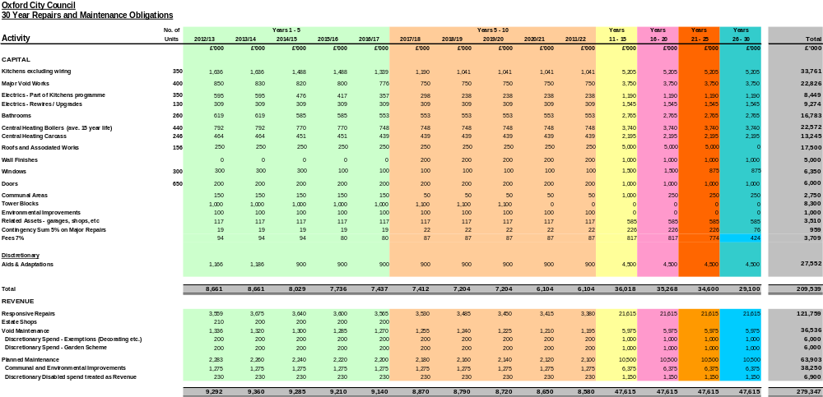

The average unit costs for works will need to be reduced over the programme to broadly in line with sector averages, meet the budget allocation and maintain current volumes, levels of service and specification. The comparison is shown below.

 | Average Unit Cost
 | Current | Average
 | £ | £
Kitchens excluding wiring | 5,500 | 3,215
Major Void Works | TBA * | 1,902
Electrics - Part of Kitchens programme | TBA* | 805
Electrics - Rewires / Upgrades | TBA* | 2,378
Bathrooms | 3,200 | 2,152
Central Heating Boilers (ave. 15 year life) | TBA* | 1,710
Central Heating Carcass | TBA* | 1,795
* To Be Advised: Direct Services/Corporate Assets

Projected Stock Condition
The main housing types are reviewed below.

Tower Blocks
The five Council tower blocks meet the Decent Homes criteria internally.

A structural investigation identified that four of the blocks had deficiencies with too few wall ties to secure the brick panels and a lack of insulation which gave rise to cold bridging and high heat loss from the buildings. There is a need for structural repair works by providing a rain-screen, which will secure the brick panels and include insulation. This will extend the life of the blocks for a further 30 years. As part of the works the installation of Cat A energy efficient double glazed windows will be included. They will be designed to retain as much heat as possible in the winter period and reflect the sun in the summer months, to make the living conditions more comfortable and provide affordable warmth for the residents.

In addition to the external envelope, the lifts need improving. There are two lifts in each block, stopping on alternate floors, which can result in difficulties for residents when a lift breaks down. It is proposed to start lift improvement works from 2017. The blocks also require improvements to the landlord’s electrical supply and fire detection works in the communal areas which will be undertaken alongside the lift works. The existing heating is electric storage heaters which is nearing the end of its life. A number of flats have already had replacements fitted. It is important to look at ways in which we improve the energy efficiency and options will be considered such as combined heat and power or similar by making use of an ESCO (Energy Supply Company) and, if possible, linking/sharing the energy source with other buildings nearby. The heating replacement programme will also begin in 2017. The tower block works would be integrated with a wider estate renewal programme.

The latest estimated cost for each block is as follows:-

Hockmore Tower £1,336,451
Plowman Tower £1,959,804
Forresters Tower £1,905,230
Windrush Tower £1,527,459
Evenlode Tower £1,527,459

The costs for the external envelope – rain-screen, insulation and windows amount to a total of £3,497,572 (£916,839 each for Forresters and Plowman Tower and £831,947 each for Windrush and Evenlode Tower) and it is this area which needs to be addressed first because of the structural issue with the wall ties (Hockmore Tower excluded).

It is proposed that works are carried out over a six year period with the following funding required:-

2011/12 £206,168
2012/13 £930,179
2013/14 £930,179
2014/15 £1,015,072
2015/16 £1,015,072
2016/17 £833,160
£4,929,830

The 2017/18/19/20 programme will include heating, electrics and lifts at an estimated sum of £3,326,572, resulting in an estimated total sum of £8,256,402 to be spent on the blocks.

Leaseholders will be recharged a proportion of the costs through their service charges, and this will vary according to the works. There are currently 38 leaseholders in the four blocks that require the structural works, and we estimate that the income from recharges may be in the order of £286,000. However, the final amount and timing of repayments will need to be considered and they have not been included in the current forecasts.

Non-traditional Homes

The Council has a number of non-traditional properties which meet the Decent Homes standard and most of which have had comprehensive repair and improvement works carried out on them in order that they have a life of at least 30 years and have a much improved carbon footprint.

B.I.S.F. (steel framed) – 131 units in Barton. The structure has been checked and new roofs, external insulated cladding and double glazed PVCu windows fitted in 2008/10. Internal decent homes works were carried out at the same time and the insulation values and appearance of the buildings have been improved considerably.

Orlits – A programme of demolition and re-builds has just been completed and the Council no longer has Orlit houses within its housing portfolio.

Aireys – 17 units in Littlemore. During 2010/11 repairs have been made to the concrete frame together with the fitting of insulated external cladding and PVCu double glazed windows. Internal works to bring the homes up to decent homes standard were carried out at the same time.

Howard Houses (steel framed) – 199 units in Rose Hill and Barton. These properties have no structural problems and external insulated cladding was installed a number of years ago but the construction has resulted in additional Decent Homes costs due to the replacement of internal wall linings. Further works will be required in the future to address the inadequacies of the lean-to conservatory on the front elevation

Minox – 190 timber framed properties in Rose Hill and Barton. There are no structural problems but the properties are poorly insulated and a pilot scheme to fix external insulated cladding is being undertaken in 2011/12 to help identify options.

Glen Lyon Bungalows – the remaining 20 units in Rose Hill were demolished to make way for a recently completed new development scheme of general needs housing with the help of grant funding from the HCA.

Hawkesley Bungalows – these aluminium clad semi-detached bungalows were extensively improved by building an external brickwork skin, with insulated cavity and the installation of double glazed PVCu windows, giving them a further 30 year life.

Easiform – although classed as non-traditional, these houses and flats were built in blockwork in a number of styles with brick or rendered block external skin. There are no structural problems and they all have cavity wall insulation and double glazed PVCu windows.

Maisonettes
The Council’s stock of one bed flats and maisonettes all meet the Decent Homes Standard. However, these properties have a poor and outdated design, and this has been associated with tenant dissatisfaction and has also attracted anti-social behaviour. There are 36 maisonette blocks with external walkway access within the city, predominantly in Blackbird Leys and the Friars Wharf area. These provide 367 homes, 80 of which have been sold and are now leasehold. The future of these blocks will be considered as part of the wider regeneration feasibility schemes for parts of the City (A7).

One Bed Flats
The Council has a stock of 1,563 one bed flats and bedsits. These meet the demand for single accommodation but do not address the most pressing need in Oxford which is for family accommodation.

Delivering energy efficiency in our homes
The Council has a priority to improve energy efficiency in its housing stock and improve insulation using of grants or other funding where possible. Examples of the areas in which energy consumption has been reduced are -

- Central Heating - “A” rated condensing boilers always fitted in new and replacement systems together with thermostatic radiator valves and modern controls.
- Top-up lofts to 250mm insulation and lagging pipes. Cavity wall insulation if needed (grant funded). External insulation to homes with no cavity and non-traditional houses – extensive works recently undertaken on BISF and Airey houses in Barton and Rose Hill.
- Increased “lagging” within central boiler rooms of sheltered schemes (grant funded).
- Double glazing (“E” glass) to over 90% of homes. New installations are to Category “A” standard.
- Biomass - Centralised biomass systems have been installed for 14 new Council flats in the centre of Oxford and as part of the refurbishment of Cardinal House sheltered housing scheme.
- Heat pumps- a new build scheme of general housing has seen air source heat pumps and solar P.V. installed in 38 properties.
- Solar hot water- a number of schemes installed on elderly persons bungalows, two blocks of flats and to a sheltered housing block, all with solar P.V. to power the pumps.
- Solar pv.- installed on the roof of Knights House, a sheltered housing scheme in Blackbird Leys, to feed the “landlords” supply with surplus being fed into the National Grid.
- A recent small scheme has resulted in the Council forming a successful partnership with Low Carbon West Oxford which provided solar pv’s on a block of five Council houses. The tenants receive free electricity and receipts from the Feed In Tariff (FIT) will go to fund additional units in the community.
- Electricity - “Sun pipes being used in sheltered scheme refurbishments to cut down on lights being used during the day.
- Low energy bulbs in all landlord supply areas in blocks of flats etc.
- Hard to treat homes - a project funded by the Strategy Technology Board and DCLG has seen the Council in partnership with Ridge & Partners and Brookes University, extensively improve an end of terrace, solid walled property through the installation of many regeneration measures, such as solar thermal hot water, solar P.V. and a heat recovery ventilation system (to improve air quality), together with improved insulation and draught proofing. The energy consumption will be closely monitored and analysed by Brookes University over the next two years to aid/inform future projects.

Next year the Government will announce the Green Deal –an initiative to establish a framework of private companies to offer consumers energy efficiency improvements to their homes, community spaces and businesses, at no upfront cost. The money will be recouped through a charge in instalments on the energy bill. The timetable is for detailed industry guidance to be prepared by Spring 2012 with the first Green Deals appearing in Autumn 2012. The Council will review the opportunities this scheme provides when the details are announced (A8)

Governance and Consultation

Governance
The Council’s current housing services governance structure is set out below. This provides for the effective direction, monitoring and review of service delivery and financial performance. The Tenants’ Involvement Monitoring Panel provides independent scrutiny, and this area is the subject of further development, described below.

Full Council

City Executive Board

Corporate Management Team

Corporate Management Team
Scrutiny Committee

Housing Landlord Services Board

Tenants’ Involvement Monitoring Panel

Housing Management Team

Operational Housing Service

Resident involvement
The Council promotes a broad range of involvement with residents and communities, including tenants and leaseholders.

Neighbourhood Management Groups and Area Fora: the Council has established these to provide a focus for engagement between communities and residents, the Council, the voluntary and third sector and service agencies and providers.

Residents Associations: the Council is promoting the extension of the network of residents associations to provide comprehensive coverage and representation for Council tenants and leaseholders at the local level.

Tenants and Leaseholders Involvement and Monitoring Panel (IMP): where customer representatives work with officers to shape and monitor the quality of our housing service. IMP members are invited to Council bodies, including:

- Scrutiny committee (finance panel) – members panel
- Scrutiny committee (housing panel) – members panel
- Housing Landlord Services Board – joint member and staff panel.

The Council is working with the IMP to review governance and to ensure that there is capacity for members to contribute their views and exercise scrutiny and to represent tenants and leaseholders effectively (A2). Following a report from the Tenant Participation Advisory Service (TPAS) on models for tenant co-regulation due in January 2012 we will be working with residents to overhaul the existing arrangements. The aim is to develop a comprehensive network of residents’ associations with representation on a single tenant and leaseholder panel. This panel will have a representative on the Housing Landlord Services Board.

Executive
The main service elements are shown in the figure below.

Income

Rents
Service Charge
Garages
Shops
Parking
Expenditure

Interest/Borrowing
Tenancy Management
Responsive Repairs
Stock Renewal
Estate Regeneration
New Development
HRA Business Plan

Governance
Planning
Monitoring
Finance
Legal
The executive team reflects these functions, supported by legal and other corporate services.

Head of Housing
Finance incl Treasury Management
Rents and other Income Collection
Asset Management

Landlord Services Manager
Planned and Responsive Maintenance
Housing Landlord Services Board
Tenancy Management

Business Plan Priorities
Tenants were consulted over their priorities for the improvement of their homes and neighbourhoods during our options appraisal in 2005. The main priority identified in this consultation was that in meeting the Decent Home standard the Council should seek to replace elements of the standard sooner and at the end of their useful life cycle as follows: 15-20 years for kitchens and 25-30 years for bathrooms, provided their condition requires this.

In developing this Business Plan, further consultation was undertaken with tenant and leaseholder representatives and with all of our tenants through:
- a newsletter and survey, and
- five residents’ consultation roadshows.

At the roadshows residents were asked three questions linked to the business plan as well as giving tenants the opportunity to comment on the priorities already identified.

The questions were:

- What work or improvements would you like to see undertaken within your home?
- What work or improvement would you like to see undertaken to the communal areas of the block you live in or to the external environment where you live?
- What improvement or changes would you like to see to the housing service the council provides (excluding repairs and maintenance)?

The results received were very positive.

In the main, and of the 35 respondents to this question, tenants were pleased with the repair service they received. The improvement they wished to see undertaken to their home was to achieve Decent Home standards, and in all cases either a new kitchen or bathroom. A small number of respondents did feel that the Decent Home replacement times should be shorter (currently 20 years for kitchens and 30 years for bathrooms.

Other responses were:

- Improved security to their home
- Showers included within decent home standard (saving water)

In regard to communal areas, responses were, again, generally positive, with comments such as “happy where I live”. Suggestions made included:

- Improved block security to flats
- Keeping gardens tidy
- Cutting trees and bushes on Magdelane college land (to discourage rats)
- Play areas for children

Finally, in response to questions about the housing service, these were mixed, a number of positive comments, such as “happy with service” were made, but other comments included:

- Difficult to get through over the phone
- Would like more information for leaseholders
- Would like leaseholder forum to be reinstated
- More help to elderly tenants, e.g. with fitting carpets
- Why has my rent gone up so much?

Performance and Service Delivery

Performance measurement
The Council’s Housing and Communities Service will measure and report progress against this financial plan and the service indicators listed below. The targets are set at or above the average for the top quartile nationally. Overall tenant satisfaction with the housing service is high: 84%. There is a corporate commitment to rise this to 87%.

Performance indicators compared to national performance levels*
[HS to complete]

Performance indicator | Top quartile average | Oxford City Council
 |  | Target | YTD December 2011 (Q3)

Income Service
% rent collected excluding arrears |  | 99% | 99%
% rent arrears of annual debit |  | 2% | 1.86%
% rent roll paid by HB |  | 52% | 52.7%
Cash value of arrears |  | <£500,000 | £617,311
Value of approved write-off |  | <£60,000 pa | £61,830
Cases served NSP (number and % arrears >6 weeks |  | Info/100% | 385/100%
Cases in court |  | Info | 70
Cases evicted |  | Info | 7
BVPI 66a (collection current rent +c/f arrears) |  | 97% | 97%
% leasehold service charge collection rate |  | 98% | TBA
% rent loss due to vacant dwelling |  | <1% | 0.7%
FTA £ total outstanding/recovery % |  | TBA | £127,008

Repair Service
Number/% RTR jobs completed within target |  | 98% | 99.93%
Number/% emergencies completed within target time |  | 100% | 100%
Number/% non-RTR jobs undertaken within target |  | 97% | TBA
Average cash value of RTR (incl mgt/admin) |  | TBA | TBA
Average cash value of non RTR (incl mgt/admin) |  | TBA | TBA
Tenant satisfaction with repair undertaken |  | 98% | TBA
Number/% pre-inspection undertaken |  | >10% | TBA
Number/% post inspection satisfactory |  | TBA | 100%

Planned Works (PPM/Cyclical)
Gas servicing completed to planned target |  | 100% | 99.72
High rise water tanks checked/cleaned to target |  | 100% | 100%
Lifts serviced to planned target |  | 100% | 100%
Lift call outs within planned time (4 hours) |  | 100% | TBA
Lift release within target time (45 mins) |  | 100% | TBA
Communal area H&S check low rise to target |  | 100% | 100%
Communal area H&S check sheltered to target |  | 100% | 100%

Voids and Allocations
Average repair time for void property |  | <17 days
Average allocation time for property in period |  | <4 days
Average void time (total) |  | <21 days | 23 days
Average repair cost for void |  | <5 days | TBA
Property let first offer |  | 75% | 78%
High priority/TR cases not bidding/inactive |  | Nil | Nil
Homeless/HWL split |  | TBA | TBA
Cases let with support |  | TBA | TBA
% New lettings satisfied with condition of property |  | 100% | TBA

Community Safety
ASB cases received |  | Info | 168
ASB cases investigated within target time |  | 95% | TBA
ASB cases actioned/closed (pre-court) within target |  | 90% | TBA
ASB cases to court (number) |  | TBA | TBA
Perpetrator: tenant/leaseholder |  | Info/info | TBA
Cases evicted (number) |  | Info | 0
% tenants satisfied with outcome |  | 85% | TBA
Hate crimes reported (number) |  | Info | 5

Community and Neighbourhoods
Number of active tenants associations |  | Info | 6
TRA meetings attended/services in a month (no/%) |  | Info | 11
Estate walkabouts undertaken |  | 3 | 0
%/number estates not meeting top standard |  | TBA | TBA
New resident groups started |  | TBA | TBA
Tenant training groups run |  | Quarterly | 3
Grant issued/% budget |  | TBA | TBA
Newsletters produced |  | Quarterly | 2

Tenancy Management
Welcome visits (no/% in target) |  | No/100% | 138
Tenancy updates undertaken |  | TBA | 202
Number of unlawful ID’s |  | Info | 0
Unlawful occupants referred for possession |  | Info | 0
Transfer cases assessed/medical cases |  | No/95% | TBA
RTB cases received |  | Info | 20
RTB sales |  | Info | TBA
Homeswapper moves in period |  | No/100% | 45/80.25%
Evictions attended/%requested to |  | No/100% | 8/75.5%

Housing Service
Complaints received |  | Info | 152
Complaints investigated in target time |  | 98% | TBA
Member and MP enquiries responded on target |  | 100% | TBA
H&S issues raised/closed (staff) |  | No/100% | 0/100%
H&S issues raised/closed (public) |  | No/100% | 0/100%
Phone calls answered within 5 rings |  | 95% | TBA
Letters responded within 10 days |  | 95% | TBA
Appointments kept within 5 days of request |  | 100% | TBA
Tenant satisfaction with housing service |  | 87% | 87%

Finance
Budget spend on profile |  | Yes | No
HRA cashflow |  | <£500 | £1,800
Compliance with BP treasury management plan |  | Yes | Yes
Housing management cost per property |  | TBA | £696
R&M cost per property |  | TBA | £869
Programmed renewals: bathroom cost per property |  | TBA | TBA
Programmed renewals: kitchens cost per property |  | TBA | TBA
Programmed renewals: rewiring cost per property |  | TBA | TBA

*Source of data ‘Housemark’, the Chartered Institute of Housing’s benchmarking service covering 95% of all social housing providers in the UK (Council, ALMO and RSL)

There are certain key indicators which are critical to the financial performance and where there is business risk. These are identified as follows:

- Rent arrears: with benefits changes and the current economic context arrears could increase. We have set a maximum target of £0.5m arrears at any time.
- Void properties: our average re-letting time is currently 23 days, placing it top quartile nationally; however, this has been targeted to be reduced to a level that is under 21 days, by April 2012, to minimise rental loss.
- Programmed renewals and reactive maintenance: we are planning for a 10% per annum reduction in costs for the initial three years of the business plan (April 2012-2015)

Service Improvement Planning

The Council has an embedded process of service improvement. This is achieved through the following:

- A commitment to deliver services in the most efficient way
- A programme of comprehensive service reviews
- Scrutiny of service performance
- Benchmarking against Councils, housing associations and service providers
- Involvement of customers and service users in defining and shaping the services.

Our service improvement planning process is therefore a wide ranging one, involving all aspects of our service and all stakeholders. In March 2011, we restructured the service creating specialist teams, improving synergies with other parts of the Council’s service, and delivered saving annually of £300,000.

Resources

Capital Payment and Borrowing Cap

Oxford City’s HRA Business Plan has been compiled using the Government’s capital valuation of the 30 year HRA notional surpluses and the Government’s latest proposed debt settlement in January 2012.

Under the HRA system Oxford City paid into the national fund £13 million per annum (negative subsidy), out of a total income of £34 million per annum. This was redistributed to Local Authorities where their HRA was in deficit. The system will end in March 2012 and a one-off capital payment made by those Local Authorities in surplus, for redistribution to those in deficit. Thereafter Local Authority stock is to be self-financing; that is income (rents and service charges) will need to cover services, new investment and any borrowing to fund the capital payment.

The Government has assessed that Oxford City Council is to pay £199.6 million when the stock is transferred out of the HRA on 31st March 2012. In addition there is already a current HRA debt charge of £20 million, borrowed from the City Council’s General Fund, making a total debt payment of £220 million. The Government has set Oxford City’s borrowing cap at £238.4 million, giving potential headroom of a further £18.8 million borrowing, if desired.

DCLG HRA Assumptions
 | Jan 2012
Headline Assumptions
Discount factor | 6.5%
Maximum Debt Settlement Figure | £238.8m
Debt Oxford CC needs to pay DCLG | £200m
HRA Existingl Debt (HRA CFR) | £20m
Borrowing potential
HRA Notional Debt (Subsidy CFR) | £38.8m
HRA Actual Debt (HRA CFR) | £20m
Borrowing potential – Headroom | £18.8m
Management and Maintenance Allowance
M&M uplift | 5.3%
Allowance | £15m
Major Repairs Allowance
MRA uplift | 34%
Uplifted MRA per unit allowance –capital spend | £xx
Consolidated average uplift | 15.8%

The main factors which will influence the final settlement are shown below.

Variable | What will be used | Effect
Retail Price Index | September 2011 | The RPI figure used in the February valuation was 3.5%. September RPI is likely to be higher. A 1% increase adds around £1billion to the national debt settlement
Dwelling information | 2012 base data | A decrease in dwellings will reduce an authority’s valuation. The mix of dwellings will affect the allowance calculations. The RTB assumptions will also be updated.
Re-lets and terminations | 2012 base data return | Relets/ terminations above the national average will increase management and maintenance allowances and reduce stock valuation.
Crime statistics | Home Office | Crime figures above the national average will increase management and maintenance allowances and reduce stock valuation.
Area cost adjustment | Local Government Finance Report for 11/12 | A higher relative increase in ACA will increase management allowances and MRA, and reduce stock valuation.
BCIS price factors | BCIS survey of tender prices May 2011 | An increase in the BCIS adjustment factor will increase maintenance allowances and MRA, reducing an authority’s valuation.
GDP deflator | Office of Budget Responsibility forecast of GDP deflator | An increase in the GDP deflator will increase the expenditure allowances and reduce all authorities’ valuations.

Treasury Management: Funding the Capital Payment and Borrowing

In principle there is a wide range of borrowing options available to Local Authorities. These include: the capital markets (such as retail or wholesale bonds and private placements), short term borrowing from financial institutions, pension fund lending, and fixed and variable borrowing (LOBO’s: lender option borrower option). Most Local Authorities are likely to have a portfolio of borrowing with variables rates and repayment profiles which balance funding requirements and value for money.

Government has announced that borrowing will be available from the Public Works Loan Board (PWLB) at a preferential rate (estimated at 3.24%) for the amount of the HRA capital payment (£200 million for Oxford City). This is the main borrowing option for most Local Authorities, including Oxford City, as it is designed to undercut the costs and fees of market solutions. This still leaves options as to borrowing the balance (up to £34 million for Oxford City), but even if this was also taken through the PWLB it would be at market rates.

In borrowing funding there are two considerations which inform the initial treasury strategy: the requirement for capital and the priority on repayment. These determine the amount of borrowing and the profile for repayment.

Our analysis shows that based on initial borrowing £199.4m for the single capital payment to Government we can also fund:

- our repairs and maintenance programme, including the tower blocks;
- deliver the current HCA affordable homes development programme (112 homes) at £17.9m (plus £2.42m HCA grant) in the period to 2015;
- fund additional new affordable homes up to £60m from 2015-21, for example at Barton.

There may be further development opportunities in the future, when there may be case for using our borrowing headroom which remains available to us. But for the present there are no additional Council developments available or other HRA capital projects, and so there is no point in increasing our borrowing at this time.

The latest discussions with Sector, our Treasury advisers identify a portfolio of PWLB loans at an average interest rate of 3.24% which is fixed at the outset and maturing between15-50 years to reflect the progressive paying down of debt, whilst retaining sufficient working capital to re-invest for development and improvement of stock. There will remain the opportunity for fresh borrowing within the overall headroom if required at a future date, but this would be at market rates.

Self Financing Housing Model

The main assumptions for the model are listed below. The initial four years cashflow forecast is shown here, with a full 30 years forecast shown in the appendices (Appendix 2)

Income

Rents
Rent restructuring remains under the automatic convergence with average formula rents, although the 2015-16 convergence date used is very unlikely to be achieved. None of our rents will exceed cap or formula rents in accordance with the rent restructuring guidance.

The Council will not be adopting ‘Affordable Rents’ (up to 80% of market rents) on re-letting its existing stock

Capped rents remain and will continue to increase as per current subsidy determination calculations: RPI + 1%. The Council has the option to determine the rent formula going forward. Actual average rent increases are based on the rent restructuring formula and this is estimated to realise slightly above 5% for the first 5 years and 3% per year thereafter. Where formula rents are achieved, future increases are estimated at 3% per year.

Limit rents also remain to protect the Exchequer and to ensure authorities do not fall foul of the Rent Rebate Subsidy Limitation calculations. We have excluded the potential option to allow average rents to increase above the level allowed in the benefit subsidy regulations covering the limit rents as there is an estimated £4.37 per week difference between our 2011/12 average rent and the 2011/12 limit rent set for OCC. The average base weekly rent for 2011/12 is £85.19.

Service Charges
The Council accounts fully for services and there are these are recharged to tenants and leaseholders. However, for tenants there is currently a service charge cap (operated by a credit) which is a cost subsidy of £700,000 per year. For over half of our tenants who are on Housing Benefit the service charge is paid by the benefit. There is a case for considering removing the limiter, possibly on a phased basis, to release more income for investment, but this has not been included in the model (A9)

Voids
The plan ignores new tenancies which will go straight to formula rent following a void period. We currently have 400 voids per year. The model cannot identify which properties become void so some will be at the formula rent and others would have been below. In the latter case, this is additional income.

An annual voids rate of 2% has been applied to the model but it is hoped that we can reduce this to 1% or less.
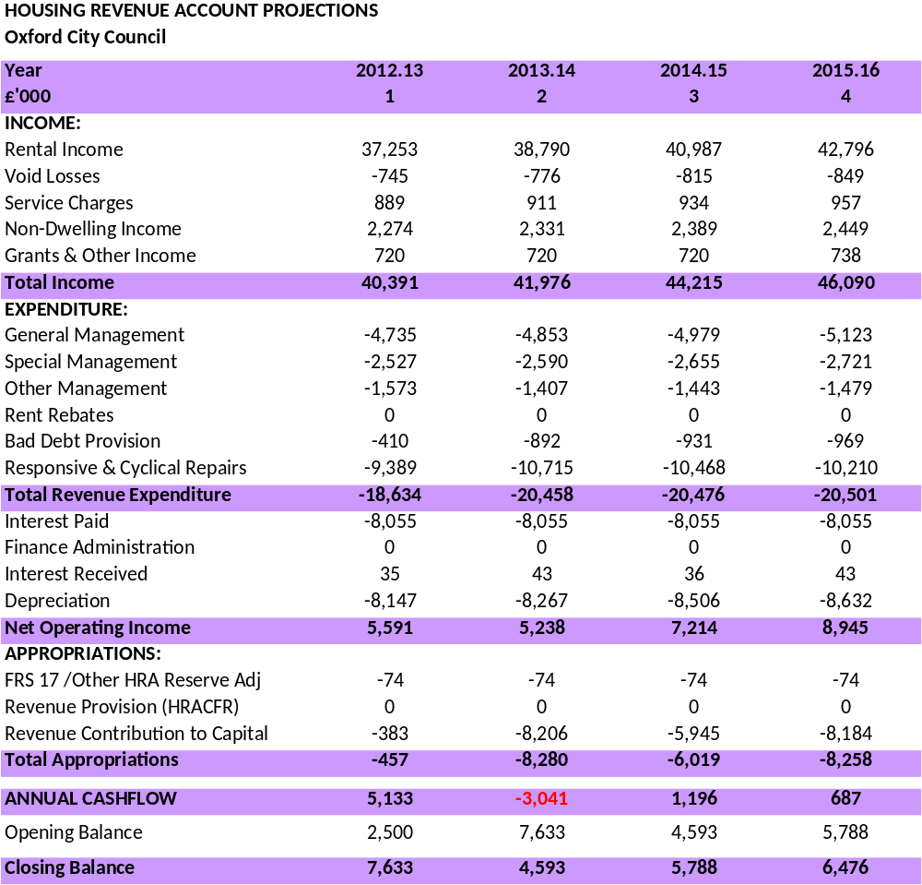
Bad Debt Provision
We have factored in an increasing bad debts provision from 1% in Year 1 rising to 2.3% from Year 3 onwards. This is due to the anticipated Housing Benefit adjustments and the introduction of the universal credit.

Stock Change: Right to Buy and New Development
RTB disposals have been profiled to result in a 10% reduction in the existing housing stock in the first 10 years 78 RTB sales per year. This is seen as a pessimistic view of the outcome of the RTB consultation, but reflects a cautious approach. We have brought in a significant reduction in property numbers in the early years of the BP to ascertain its robustness. From year 11 onwards RTB sales are included at 10 disposals per year. In line with the consultation we have assumed the first £30,000 capital receipt of each RTB disposal will be set aside to cover the self-financing debt per unit, and the remaining £17,000 capital receipt be made available for the General Fund capital programme..

The business plan provides financial capacity to deliver 112 new homes through the HCA Affordable Homes Programme in the first three years of the programme at a cost of £17.9m plus £2.5m HCA grant. The model does not include income from new development. First, the development programme will not be confirmed with HC until March 2012. Second, the additional income provides a potential offset if there is a substantial increase in Right to Buy stock losses.

The Council also has the ambition to develop more new affordable homes. For example the Council may decide to own the affordable homes in the Barton development (around 400 new homes). Other opportunities remain to be identified at this stage. The business plan has the capacity to fund £60m of new development to 2020/21.

Non-Dwelling Property
We expect an annual income £580,000 from shops and £800,000 from garages in Year 1. Annual uplifts to these figures have been applied at 2.50%.

The potential option to transfer these assets to the General Fund will be explored (A10) as there are several technical accounting regulatory adjustments that need to be satisfied. These assets are not included in the Government’s HRA payment and debt cap calculations. Transferring these assets to the General Fund may allow the Council additional borrowing capacity for housing investment.

Expenditure
Direct Service Costs
Annual uplifts have been applied to the rest of repairs at 2.50%.

The Council’s Direct Services are responsible for undertaking a range of works contracts covering: programmed renewals, cyclical maintenance, re-letting and void works, environmental works, garages and shops, aids and adaptations.

The 30 year programme expenditure equates to around £59,500 per dwelling. This is towards the higher end of national average benchmarks of £55,000 to £60,000-but will still require significant changes to achieve this through improved efficiency and reduced costs. This in turn will release funds for further investment in our stock and new development. Increasing stock through new development may also assist in reducing fixed overhead costs. A full service review of repairs and maintenance costs is planned for 2012 (A11).
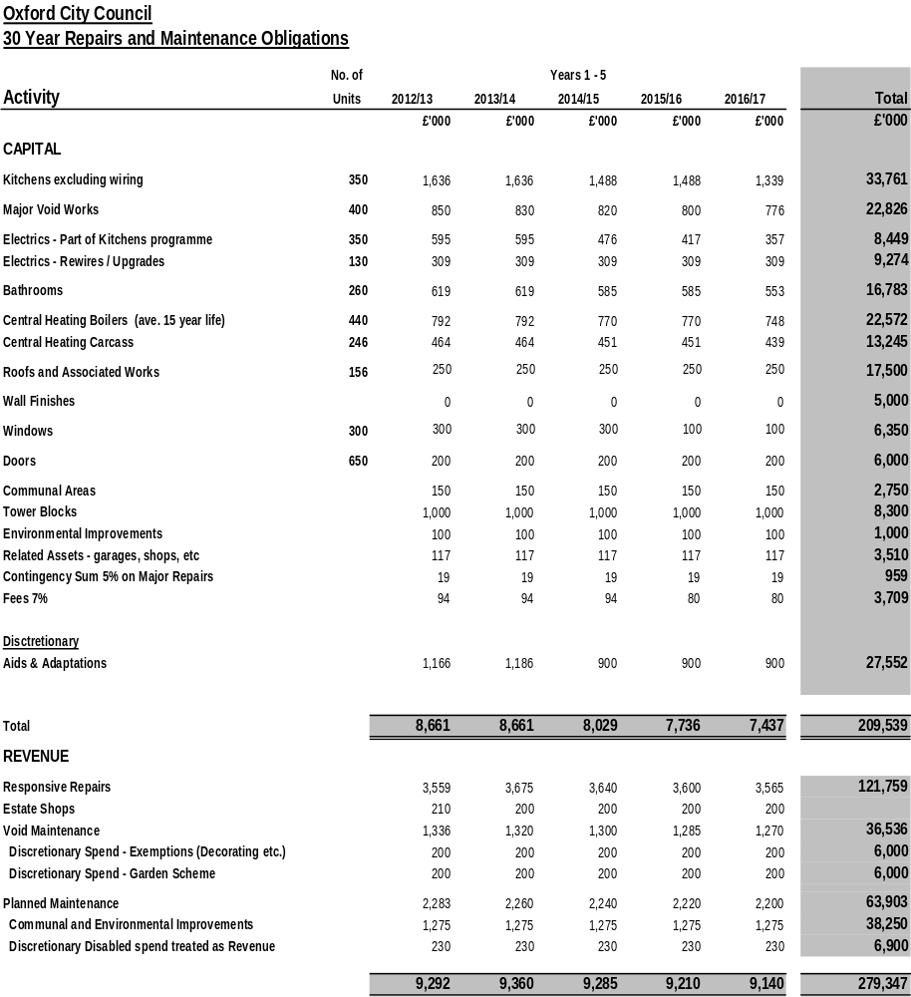

Average total cost per property (30 years) | £59,500
Base year: August 2011 | 7,799 homes

Programmed Renewals
These works are planned for replacement based on an average life cycle. In some cases elements will extend beyond their average life, whilst others will need replacing earlier. For efficiency and safety it is usually best to group renewals rather than wait for the individual failures to arise. For example we assume replacing bathrooms every 30 years, kitchens every 20 years, and boilers every 15 years. The elements and inclusive unit rates adopted are listed below, including management, works and supply of materials.

Description | Unit Rate/Dwelling
Kitchens | £3,215
Kitchens: electrics / wiring | £805
Bathrooms | £2,152
Re-wiring | £2,378
Central heating boilers | £1,710
Central heating carcass | £1,795
Voids-major works | £1,902

The current charges by Direct Services will be reduced during the initial years of the Business Plan with the largest reductions being planned from year three of the programme of works.. In general terms it will require efficiencies of around 10% per year, for example reducing kitchen costs from £5,500/dwelling and bathrooms from £3,200 without reducing the quality or specification.

Tower Blocks
A total of £8.25 million programmed expenditure is included to bring the five tower blocks to a good standard and provide a further 30 year minimum life. A proportion of this expenditure is recoverable through service charges. At this stage we have not made provision for any recovery. For tenants on benefits, there will be a cap on recoverable charges. For tenants who are not on benefits and leaseholders, whilst they may be liable for full recovery of service costs, many will not have adequate means to support this. The Council will need to devise an appropriate strategy (A12)

Cyclical Maintenance
This is a planned programme for redecoration and routine maintenance. Whilst there is some flexibility in timing, it is limited. At present the cost is £1,200 per dwelling and we have planned to reduce this by 5% in the initial 5 years, and thereafter progress to a benchmark cost of £700 per dwelling over the following 5 years.

Responsive and Void Maintenance
This expenditure covers call-out repairs and works to refit properties for new tenants. It is essentially demand driven, and is an estimate based on previous experience and national benchmarks.

Environmental Works
This covers works to common areas such as common parts and stairways, lighting, and external grounds.

Garages/Shops/Other
The Council needs to meet repairs and maintenance liabilities for these assets.

Contingency: this allowance reflects the need to provide for some more extensive repairs where we have to undertake unforeseen major or structural works.

Fees
This covers external professional fees for major works, such as the tower blocks.

Aids and Adaptations
We have maintained a significant budgetary provision that does not fall below £0.9m per annum. This budget is discretionary and covers a wide range of support, from funding adaptations/extensions to Council housing (in some cases up to £50,000) to stair rails and steps. To date the Council has funded almost all the applications, and this is above levels compared with some other Local Authorities. For example, some Local Authorities now require applicants who have the financial means to contribute to works, or effectively ration access to adapted flats through a waiting list. With an ageing population costs will escalate, and we would wish to develop a fair and transparent strategy with Members to manage the programme within the current budget (A13).

In addition there are gardening and decoration services which are provided to elderly and disabled persons (£0.2m per annum) which should be reviewed (A14).

Borrowing
Finance Rate
The Government have recently announced that for Self-Financing borrowing they are proposing that PWLB will charge pre Comprehensive Spending Review rates: 11-15 points above gilt prices, 85-89 basis points below prevailing rates. It is difficult to see how this can be bettered and this is expected to be the one preferred by Sector our Treasury Advisors. Using current PWLB rates normal 30 year maturity borrowing rates are 4.16%.

However, the rates are subject to daily changes between now and the last day we can apply for PWLB Self-Financing loans is 26 March 2012. Given there is potentially changes to the capital investment requirements the maturity periods that may be used and subsequently advised by Sector will be subject to change, as the borrowing cash flows need to mirror the capital investment requirements.

Interest on Positive Balances
Interest earned on cash balances has been estimated at 0.7% LIBD rate.

Capital Finance Requirement
Subject to reviews required to reconcile the GF and HRA Capital Finance Requirements (CFR) the assumed actual HRA CFR at the beginning of 2012/13 is £23 million.

The debt cap from the DCLG valuation is £242 million.

Our potential headroom would £19 million .Any expenditure in the current year over and above in-year MRA should be funded from existing HRA reserves that currently stand at £2.6m as at 31 March 2011.There is an assumed nil balance on the Major Repairs Reserve at the beginning of 2012/13. Whilst the data is only relevant for 2011/12 some base plan assumptions are still required to be estimated and these include MRA uplifts, management and maintenance allowance uplifts, estimates for tenants in receipt of benefit, allowable debt management expenses, GDP uplifts. A minimum HRA balance of £3m is initially identified as a prudent position to adopt in the early years of the BP.

Depreciation
Depreciation has been increased to the higher levels from c. £5.5m to over £8m to reflect the increases in spend. This is to ensure that under the transitional arrangements CIPFA have introduced regarding the change in depreciation measurements that OCC HRA is robust enough to accommodate and fund an £8m/year capital expenditure programme for our existing housing stock..

Repayment Profile
The repayment profile is assumed as follows:

£m | Period (Years) | Redemption
20 | 15 | 2027
20 | 20 | 2032
25 | 25 | 2037
25 | 30 | 2042
25 | 35 | 2047
25 | 40 | 2052
30 | 45 | 2057
29.61 | 50 | 2062
£199.61m

Financial Capacity
The assessed financial capacity is based on the following assumptions:

Debt Cap | £242m
Less HRA Self-Finance Payment | £200m
Less HRA Debt Existing | £23m
Net Borrowing Capacity | £19m

Additional Commitments
As indicated above, there is potential financial capacity to fund additional commitments over the life of the 30 year programme and beyond as well as pay down borrowing.

The opportunities identified are set out in broad order of priority on the basis of the following themes:
- New and affordable homes to address the housing shortage
- Estate regeneration
- Energy efficiency, carbon reduction and reducing fuel poverty
- Improving the quality of the existing stock and renewals.

New and Affordable Homes

HCA Affordable Homes Programme
The Council has successfully bid for programme funding to deliver 112 new homes in the period 2012-2015. The programme comprises the redevelopment of an existing sheltered housing block (Bradlands: 40 homes) together with a range of small surplus sites in the Council’s ownership which would otherwise be sold and are beneath the Sec 106 Planning Obligations requirement to contribute to affordable housing (less than 10 homes). The programme provides for 68 homes at social rents. The balance of the programme will be higher ‘Affordable Rents’ to provide accommodation for homeless persons who would not otherwise find housing at market rents in the private rented sector. The HCA grant is £2.42 million with the balance of £17.9 million funded by the HRA (A15).

Barton Development
The Council has a partnership with Grosvenor Developments to deliver over 900 new homes over the next 10-15 years, with a minimum of 40% affordable social rent. The Council may elect to develop, fund and manage the affordable stock. This might be partly or fully funded through the HRA. The Council will review the financial options (A16).

Estate Regeneration

There is a range of opportunities for redevelopment within the existing housing estates. These have the potential to release opportunities for new affordable homes as well as to contribute to improving the environment and services on our estates. They may also provide for the decanting and demolition of stock such as the maisonettes in due course (A7).

Energy Efficiency and Carbon Reduction

The Council has already undertaken a wide range of initiatives to improve energy efficiency, including tacking our non-standard housing stock. The proposed tower block programme will improve 400 flat and raise their thermal standards to acceptable levels. With new additions to our stock we have introduced bio-mass boilers and are investigating options for CHP and other low carbon solutions. We are also pursing PV options for selected housing blocks. The Government’s Green Deal next year gives us the potential opportunity to develop a wider and more holistic strategy for our stock (A1 and A8).

.Improving the Quality of Existing Stock and Renewals

The business plan provides for the continued renewal of bathrooms and kitchens to the Decent Homes standard, as well as the necessary safety repairs and maintenance of energy supplies. This is a modest standard and the Council would wish to explore the options to raise this to a higher Oxford standard. However, this option can only be progressed if efficiencies in the current cost of renewals identified in the business plan are delivered as a priority (A17).

APPENDICES

- Action Plan
- Self-Financing Model 30 Year Cashflow
- Risk Assessment

Action Plan | Appendix 1

 | Action | Elements | Start | Complete | Finished
A1 | City Homes Energy Efficiency Strategy | Work with Low Carbon Oxford to develop comprehensive strategy | 3/12 | 9/12
A2 | Tenant Engagement and Governance Strategy | Undertake review with existing Improvement Monitoring Panel  Implement strategy including resident groups framework | 11/11  4/12 | 2/12  7/12 | /
A3 | Local Offer and Service Standards | Tenants roadshows  Develop Local Offer and service standards  Implement and monitor | 11/11  12/11  4/12 | 11/11  1/12 | /
A4 | Residents Profile | Develop data capture framework  Implement and monitor | 4/12  7/12 | 6/12
A5 | Planned Renewals Profile | Review with City Services | 11/11 | 1/12
A6 | Stock Condition Survey/Software Review | Stock survey framework  Software review  Implement annual survey | 1/12  1/12  5/12 | 3/12  3/12  4/17
A7 | Estate Regeneration Strategy | Blackbird Leys strategy development  Donnington strategy development | 10/12  10/12 | 4/12  4/12
A8 | Green Deal Programme
A9 | Service Charge Cap Review | Commission review and report  Implement changes | 1/12  4/12 | 3/12  4/15
A10 | Non-Commercial Assets Transfer | Review options | 11/11 | 12/11
A11 | Direct Services Review | Specification  Commission and report | 1/12  4/12 | 3/12  10/12
A12 | Tower Blocks Service Charge Recovery | Strategy review | 4/12 | 5/12
A13 | Aids and Adaptations Review | Strategy review | 1/12 | 3/12
A14 | Gardening and Redecoration Review | Strategy review | 1/12 | 3/12
A15 | HCA Affordable Homes Programme | Programme development  HCA contract | 10/11  1/12 | 12/11  3/12 | /
A16 | Barton Affordable Homes Strategy |  | 11/11 | 3/12
A17 | Planned Renewals: Oxford Standard | Options review | 6/12 | 9/12

HRA Financial Projections | Appendix 2

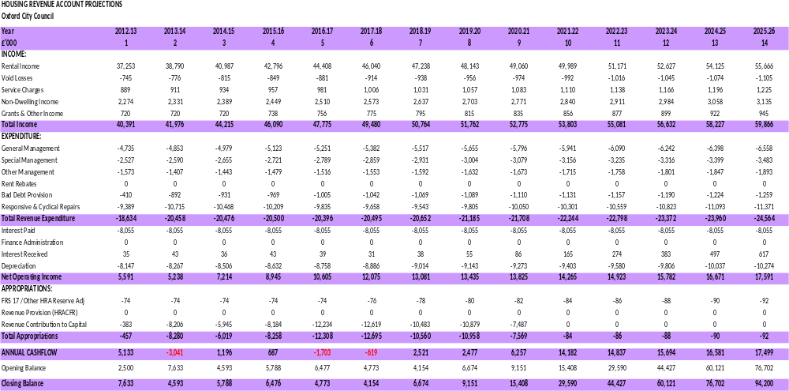

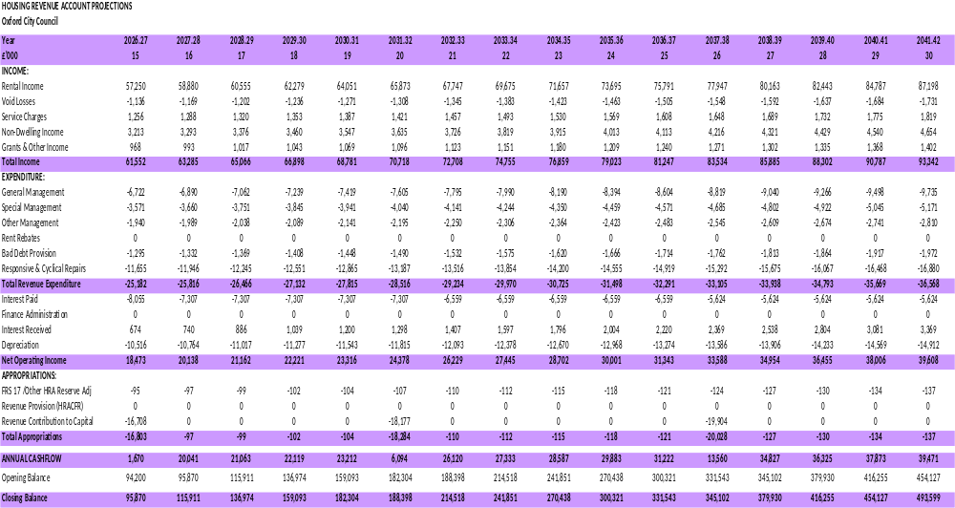

Risk Assessment | Appendix 3



